Conditional Operator (? :)
// largest among three numbers
#include<stdio.h>
void main(void)
{
int a,b,c,temp,largest;
a=100;
b=20;
c=500;
temp = a>b?a:b;
largest = c>temp ? c: temp;
printf("Largest is %d", largest);
}
// Largest among 3 Numbers
#include<stdio.h>
void main()
{
int a, b, c;
printf(“Pls Enter three Num:”);
scanf(“%d%d%d”,&a,&b,&c);

if(a>b)
{
if(a>c)
printf(“Largest is %d”,a);
else
printf(“Largest is %d”,c);
}
else
{
if(b>c)
printf(“Largest is %d”,b);
else
printf(“Largest is %d”,c);
}
// odd or even number
Odd 1,3,5,7
Even 2,4,6,8
% remainder
#include<stdio.h>
void main()
{ int number;
printf("\nEnter the number:");
scanf("%d",&number);
if(number%2==0)
{ printf("\nThe entered number is even"); }
else
{
printf("\nThe entered number is odd");
}
}

Calculate the area of a triangle. (area = 1/2 * base * height)
#include<stdio.h>
void main()
{
float area, b, h;
printf(“Enter base and height triangle:”);
scanf(“%f %f”, &b, &h);
area=0.5*b*h;
printf(“The area is %f“, area);
}
Write a program for converting a given temperature in Centigrade scale to Fahrenheit scale.
F= C * 1.8 + 32
swap two numbers
without the use of a temporary variable
#include<stdio.h>
void main( )
{
int a, b;
a=10;
b=50;
a = a + b; // a=60
b = a – b; // b=60-50=10
a = a – b; // a= 60-10 =50
printf(“\nThe swapped numbers are a = %d\t b = %d”, a, b);}
Write a C program to convert given days to months and days
#include<stdio.h>
void main( )
{ int days, months;
printf(“Enter the number of days:”);
scanf(“%d”, &days);
months=days/30;
days = days%30;
printf(“Months:\tDays:\n”);
printf(“------\t----\n”);
printf(“%d\t%d”, months, days);
}

Write a program in C to generate the following series of numbers

1
2 1
3 2 1
4 3 2 1
5 4 3 2 1
6 5 4 3 2 1

#include <stdio.h>
#include <stdlib.h>

int main()
{ int a,i,j;
printf("Enter the number of rows :");
scanf("%d",&a);
for(i=0;i<=a;i++)
{
for(j=0;j<i;j++)
{
printf("%4d",i-j);
}
printf("\n");
}

return 0;
}

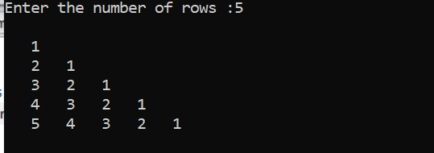

Assignment

#include<stdio.h>
int main(void)
{
for ( int num = 1 ; num <= 10 ; num++ )
{
if ( num > 4 )
break ;
printf( "%2d" , num ) ;
}
return 0;
}
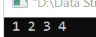
#include<stdio.h>
int main(void)
{
for ( int num = 1 ; num <= 10 ; num++ )
{
if ( num == 4 )
continue;
printf( "%2d" , num ) ;
}
return 0;
}

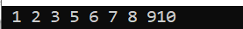

#include<stdio.h>
int main(void)
{
int num =1;
while (num++<=15)
{
if (num ==4)
continue;
printf("%4d",num);
}
return 0;
}

#include<stdio.h>
int main(void)
{
int num =5;
int a;
a=num--*6;
printf("num is %2d, a is %2d",num,a);

return 0;
}
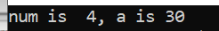
#include<stdio.h>
#include<ctype.h>
int main(void)
{
char choice;
printf("Pls Enter Choice: R or W or B\n");

switch(choice = toupper(getchar())){
case 'R' :
printf("RED");
break;
case 'W' :
printf("WHITE");
break;
case 'B' :
printf("BLUE");
break;
default :
printf("ERROR");
break;
}
return 0;
}

Assignment

#include<stdio.h>
#include<ctype.h>
int main(void)
{
int num=0;
for(;num<=9;)
printf("%d\n", num++);
return 0;
}

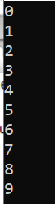

#include<stdio.h>
#include<ctype.h>
#include<math.h>
int main(void)
{
float sum=0, sumsq=0,sumsqrt =0, x;
printf("Pls enter the value of x\n");
scanf("%f", &x);
while(x!=0)
{
sum +=x;
sumsq +=x*x;
sumsqrt += sqrt(x);
printf("Sum is %f, Sum of square is %f, sum of square root is %f\n", sum,sumsq,sumsqrt);
printf("Pls enter the value of x\n");
scanf("%f", &x);
}
return 0;
}

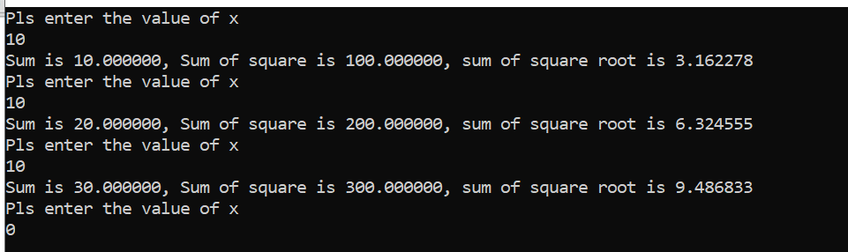
Q10 | Write a string program that will copy one string to another
#include<conio.h>
#include<string.h>
int main(void)
{

char string1[80]="Waljat Colleges";
char string2[80];
int size,i;
printf("String1 is %s",string1);
for( i=0;string1[i]!='\0';i++)
{
string2[i]=string1[i];
}
string2[i]='\0';
printf("\nString2 is %s",string2);
return 0;
}
Q11 | Write a program that will add two strings
#include<stdio.h>
#include<stdio.h>
#include<conio.h>
#include<string.h>
int main(void)
{

char string1[80]="Waljat Colleges";
char string2[80] = " Of Applied Sciences";
int size,i;
printf("%s\n",string1);
printf("%s\n",string2);
// Add two String
size=strlen(string1);
int j;
for( i=0,j=size-1;string2[i]!='\0';i++,j++)
{
string1[j]=string2[i];
}
printf("\nAdd Two String :\n:");
printf("%s\n",string1);
return 0;
}
 | 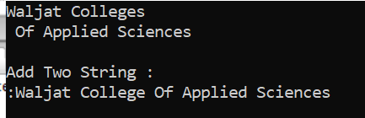
Q12 | Write a program that will compare two strings.
#include<stdio.h>
#include<conio.h>
#include<string.h>
int main(void)
{

char string1[80]="Waljat Colleges";
char string2[80] ="Waljat Colleges";
int s1,s2,flag=0,i;
s1=strlen(string1);
s2=strlen(string2);
if(s1 != s2)
printf("Strings are not equal :");
else
{
for(i=0;i<s1;i++)
{
if(string1[i]!=string2[i])
{
flag=1;
break;
}

}
if(flag==1)
{
printf("\nNot Equal:");
}
else
printf("\nEqual:");
}
return 0;
}

Pointer
“Pointer contain memory addresses not data values.”
data type *pointer_name;
e.g.
int *ptr;
Here ptr is a pointer, which is going to contain address of an integer variable.
char * ptr;
Here ptr is a pointer, which is going to contain address of a character variable.
Address operator (&)
The operator & is “address of” operator.
e.g.
int x;
if we write &x, it means address of x.
Consider the following
int x;
x=22;
x
22
1002
here x is a variable name.
22 is the value of variable.
1002 is the address of variable x.
printf(“\n address of x = %u”,&x);

int *ptr;
we can assign ptr to the address of variable x.
ptr = &x;
&x means address of variable x.
We can also write the above statements as follows:
int x;
x=15;
int *ptr =&x;
printf(“\n address of x = %u”,&x);
printf(“\n address of x = %u”,ptr);
both above statements will print the same address of variable x.
Value at operator / Indirection operator (*)
The operator “ * ” is “value at” operator.
Now consider the following statements
printf(“\n address of x = %u”,&x);
printf(“\n address of x = %u”,ptr);
printf(“\n value of x = %d”, x);
printf(“\n value of x = %d”, *(&x));
printf(“\n value of x = %d”, *ptr);
The first two statements will print the address of variable x.
Next three statements will print the same value of x.
*(&x) means value at address of variable x.
*ptr means value at address contain in variable ptr.

#include<stdio.h>
void main()
{
int x;
x=15;
int *ptr =&x;
printf("%d %u",x,&x);
printf("\n%u %d",*ptr,ptr);
}

Pointers and Arrays
Pointer can point to entire array instead of a single variable.
In C array name is the base address (starting address of an array). Adding one to the array name can move a pointer to the next array element, add another one and the pointer moves to the element after that, and so on… In this manner the entire array can be indirectly accessed with a pointer variable.
Consider the following array declaration
int a[5];
In C array name can be used as base address of an array.
22 | 33 | 55 | 28 | 59
Addresses 12228 12230 12232 12234 12236
a[0] a[1] a[2] a[3] a[4]
(a+0) (a+1) (a+2) (a+3) (a+4)
The following two statements do the exact same thing:
a[1] = 33;
*(a+1) = 33;
Now consider the following statements
int a[5] = {22, 33, 55, 28, 59};
int *ptr;

ptr = &a[0];
or
ptr = a;
both above statements are same. In C array name represents the base address (0th element address).
Now ++ptr;
Will represent the (ptr+1) element or (a+1) element or a[1] element of an array.

#include<stdio.h>
void main()
{

int a[5] = {22, 33, 55, 28, 59};
int *ptr;
ptr=&a[0];

for (int i=0;i<5;i++)
{
printf("%4d %4d \n",a[i],*ptr);
ptr++;
}
}

